|  |
| --- |
| **SDK and System Resources of**  **B3VCU**  **STELS PART NO: 2200302054** |

**Change Index.**

|  |  |  |  |  |
| --- | --- | --- | --- | --- |
| Index | Date | Amendment contents | Version | Person |
| 1 | 07 July2022 | First Copy for release | 1.0.1 | Chen Yong |
| 2 | 3 Aug 2022 | Modify by VCU_IDS_V0.2.xlsx requirement | 1.0.2 | Chen Yong |
|  |  |  |  |  |
|  |  |  |  |  |
|  |  |  |  |  |
|  |  |  |  |  |
|  |  |  |  |  |
|  |  |  |  |  |
|  |  |  |  |  |
|  |  |  |  |  |
|  |  |  |  |  |
|  |  |  |  |  |
|  |  |  |  |  |
|  |  |  |  |  |
|  |  |  |  |  |
|  |  |  |  |  |
|  |  |  |  |  |
|  |  |  |  |  |
|  |  |  |  |  |
|  |  |  |  |  |
|  |  |  |  |  |
|  |  |  |  |  |
|  |  |  |  |  |

**Table of Contents**

1 Scope 4

2 System 4

3 Environment 5

3.1 VCU 5

3.2 Programming computer 6

4 B3VCU system resources 6

4.1 External interface 6

4.1.1 CAM UART 6

4.1.2 VDU UART 6

4.1.3 Spare UART 7

4.1.4 Ethernet 7

4.1.5 Keypad 7

4.1.6 Digital GPIO Output 7

4.1.7 SDI Video Input 8

4.1.8 SDI video Output 8

4.1.9 LED 8

4.2 Internal Interface 9

4.2.1 I2C 9

4.2.2 frmbuf_rd 9

4.2.3 mix 9

4.2.4 uhdsdi_tx 9

4.2.5 sdi_anc_tx 10

4.2.6 IIo sensor 10

4.2.7 pdma 10

4.2.8 Reserve memory 10

4.2.9 Watchdog 10

5 Programming 11

5.1 A simple firmware 11

5.1.1 Edit 11

5.1.2 Compile 12

5.1.3 Run firmware 12

# 1 Scope

This document stipulates SDK -System resources specification procedures for Video Control Unit (abbreviated as VCU B3 here after). This document will be used as a guideline to system resources and programming of VCU B3 in according to the technical specification requirements.

# 2 System

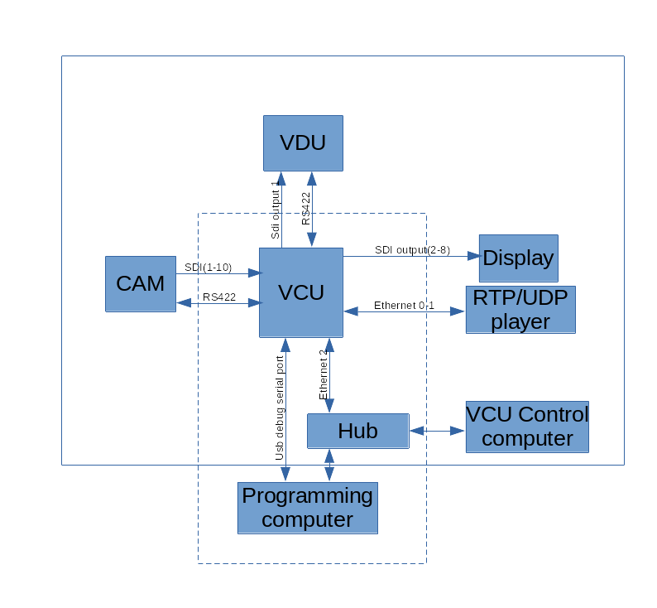

Figure is the full system physical linking. The devices and linking for programming are in the dotted line box.

# 3 Environment

## 3.1 VCU

Default setting:

* static IP (192.168.1.254)
* username: root
* password: root

The user can download and upload files to VCU with sftp client software.

The user can control the VCU with the serial port debug application (e.g: teraterm).

The user also can log in and control the VCU with putty or ssh.

## 3.2 Programming computer

* This computer is for programming the software for the VCU. The Ubuntu (20.04) is required and verified to work.
* This computer has the same subnet IP address with the VCU.
* The user need install the requirement software eg Filezilla(sftp client), GTKTerm(serial debug) or ssh for downloading, uploading and debugging the VCU files.
* The user run sdk.sh(from teamone) to install the sdk compiler.
* <your-sdk-dir>/environment-setup-cortexa72-cortexa53-xilinx-linux includes the environment setup for the compiler. The user need setup the environment of the compiler based on their SDK requirement.

# 4 B3VCU system resources

## External interface

### 4.1.1 CAM UART

This port is link to the TI camera for the NUC controlling.

***Physical link****:* ***TIA/EIA-422***

***Device name****: /dev/ttySC0*

***working mode****: Duplex*

***flow control****: no*

## 4.1.2 VDU UART

This port is link to the VDU for the VDU switching command.

***Format****:* ***TIA/EIA-422***

***Device name****: /dev/ttySC1*

***working mode****: Duplex*

***flow control****: no*

## 4.1.3 Spare UART

***Format****: TIA-232*

***Device name****: /dev/ttyPS1, /dev/ttySC2, /dev/ttySC3*

***working mode****: Duplex*

***flow control****: no*

## 4.1.4 Ethernet

1**0/100/1000 BASE-T**

* **Port 1(eth2):** VCU control port. default static IP 192.168.1.254
* **Port 2(eth0):** VCU RTP video stream port. Default Static IP 192.168.6.254
* **Port 3(eth1):** VCU RTP video stream port. Default Static IP 192.168.7.254

### 4.1.5 Keypad

|  |  |  |  |  |
| --- | --- | --- | --- | --- |
| Key No | Gpio port | Key name | Linux code |  |
| KEY_DIN_1 | <axi_gpio_0 0> | key1 | KEY_1(2) | Trailer ? |
| KEY_DIN_2 | <axi_gpio_0 1> | key2 | KEY_2(3) | Reverse Gear |
| KEY_DIN_3 | <axi_gpio_0 2> | key3 | KEY_3(4) | Forward Gear |
| KEY_DIN_4 | <axi_gpio_0 3> | key4 | KEY_4(5) | TBD |
| KEY_DIN_5 | <axi_gpio_0 4> | key5 | KEY_5(6) | TBD |
| KEY_DIN_6 | <axi_gpio_0 5> | key6 | KEY_6(7) | TBD |
| KEY_DIN_7 | <axi_gpio_0 6> | key7 | KEY_7(8) | TBD |
| KEY_DIN_8 | <axi_gpio_0 7> | key8 | KEY_8(9) | TBD |

### 4.1.6 Digital GPIO Output

|  |  |  |  |
| --- | --- | --- | --- |
| DO No | Linux GPIO No | Terminal | Description |
| DO1 | 492 | IR | On/OFF IR |
| DO2 | 493 | IR | On/OFF IR |
| DO3 | 494 | TBD |  |
| DO4 | 495 | TBD |  |
| DO5 | 496 | TBD |  |

### 4.1.7 SDI Video Input

**Device name**: /*dev/media6 (/dev/video0)*

*/dev/media7 (/dev/video1)*

*/dev/media8 (/dev/video2)*

*/dev/media9 (/dev/video3)*

*/dev/media0 (/dev/video4)*

*/dev/media1 (/dev/video5)*

*/dev/media2 (/dev/video6)*

*/dev/media3 (/dev/video7)*

*/dev/media4 (/dev/video8)*

*/dev/media5 (/dev/video9)*

### 4.1.8 SDI video Output

*SDI0 output: frmbuf_rd --> mix -> uhdsdi_tx (‘mix’ can mix video and osd)*

*SDI1 – SDI7 output: frmbuf_rd->udhsdi_tx. (without osd funciton)*

*There is a device “sdi_anc_tx” in all output. It can embed timestamp into the SDI signal.*

*all devices refer to internal interface:*

*frmbuf_rd: refer to 4.2.2*

*mix: refer to 4.2.3*

*uhdsdi_tx: refer to 4.2.4*

*sdi_anc_tx: refer to 4.2.5*

### 4.1.9 LED

|  |  |  |
| --- | --- | --- |
| LED | Linux GPIO No | Description |
| Green | 458 | Normal Status |
| Red | 459 | BIT error |

## 

## 4.2 Internal Interface

### 4.2.1 I2C

**device name**: /*dev*/i2c-0

**slave chip**: mb85rc256vfp **slave address**: 0x50

**description**: log data storage

### 4.2.2 frmbuf_rd

**Address**: sdi0(0xb02d0000) sdi1(0xb02f0000) sdi2(0xb0310000) sdi3(0xb0330000) sdi4(0xb03a0000) sdi5(0xb03c0000) sdi6(0xb03e0000) sdi7(0xb0400000)

**Support Format**: Y_UV10, Y_UV8

refer to document (pg278-v-frmbuf.pd) provided by Xilinx

### 4.2.3 mix

**Address:** 0xb02e0000

**Primary video format**: YUV4:2:2 10bits

**Overlay layer1 format**: BGRA8

**Maximum resolution**: 1920x1080

refer to document (pg243-v-mix.pdf) provided by Xilinx

### 4.2.4 uhdsdi_tx

**Address**: sdi0(0xa0040000) sdi1(0xa0060000) sdi2(0xa0080000) sdi3(0xa00a0000) sdi4(0xa0100000) sdi5(0xa0120000) sdi6(0xa0140000) sdi7(0xa0160000)

**Mode**: 3G SDI 10bits

**format**: NV16_10LE32

refer to document (pg289-v-smpte-uhdsdi-tx-ss.pdf) provided by Xilinx

### 4.2.5 sdi_anc_tx

**Address**: sdi0(0xa01c0000) sdi1(0xa01d0000) sdi2(0xa01e0000) sdi3(0xa01f0000) sdi4(0xa0200000) sdi5(0xa0210000) sdi6(0xa0220000) sdi7(0xa0230000)

**data format**: 64bits unsigned interger. Microseconds of the epoch time.

### 4.2.6 IIo sensor

CPU:/sys/bus/iio/devices/iio\:device0

Power Current Sensor:/sys/bus/iio/devices/iio\:device1

### 4.2.7 pdma

It is a user interface to transfer a DAM address of the user space to the physical address.

**Device**: /*dev*/pdma0

**ioctl cmd**: 0

**ioctl parameters**: struct{guint64 param_in; guint64 param_out}

param_in: the dma user-space address.

param_out: the dma physical address

### 4.2.8 Reserve memory

**reserve memory physical address**:0x70000000

**reserve memory size**: 0xff00000

### 4.2.9 Watchdog

**Device**: /*dev/watchdog0, /dev/watchdog1*

*watchdog0 is controlled by OS.*

*Watchdog1 can be controlled by the user.*

# 5 Programming

## 5.1 A simple firmware

### 5.1.1 Edit

Install Atom as the SDK editor. Install Atom requirement plugin.

Create the Project Folder and Add this project folder into the Atom.

create a new file ‘Makefile’ and a folder ‘src’ in this project folder.

Create a source file ‘main.c’ in the folder ‘src’.

**edit Makefile:**

TARGET := $(notdir $(CURDIR))

CSOURCES := $(wildcard src/*.c)

COBJECTS := $(CSOURCES:%.c=%.o)

CPPSOURCES := $(wildcard src/*.cpp)

CPPOBJECTS := $(CPPSOURCES:%.cpp=%.o)

CFLAGS := -O

LDFLAGS :=

LIBS :=

.PHONY: $(TARGET)

$(TARGET): $(COBJECTS) $(CPPOBJECTS)

$(CXX) -o $@ $^ $(LDFLAGS) $(LIBS)

$(COBJECTS): %.o: %.c

$(CC) $(CFLAGS) -o $@ -c $<

$(CPPOBJECTS): %.o: %.cpp

$(CXX) $(CFLAGS) -o $@ -c $<

clean:

rm -rf *~ .dep $(COBJECTS) $(CPPOBJECTS) $(TARGET)

**edit the main.c:**

#include <stdio.h>

int main()

{

printf(“hello world!\n”);

return 0;

}

### 5.1.2 Compile

Open Terminal and Go to your project folder. Run “make”.

Then you get a executable file ‘<your-project-folder>’ in <your-project-folder>.

### 5.1.3 Run firmware

* Download the executable file to /*usr/local/bin in the VCU with the sftp client software*
* *Open GTKTerm and connect to the VCU with the USB debug port.*
* *(e.g /dev/ttyUSB0)*
* *Disable the original VCU firmware in /etc/init.d/loaduserapp.sh and reboot the VCU*
* *go to the folder /usr/local/bin and run your application*